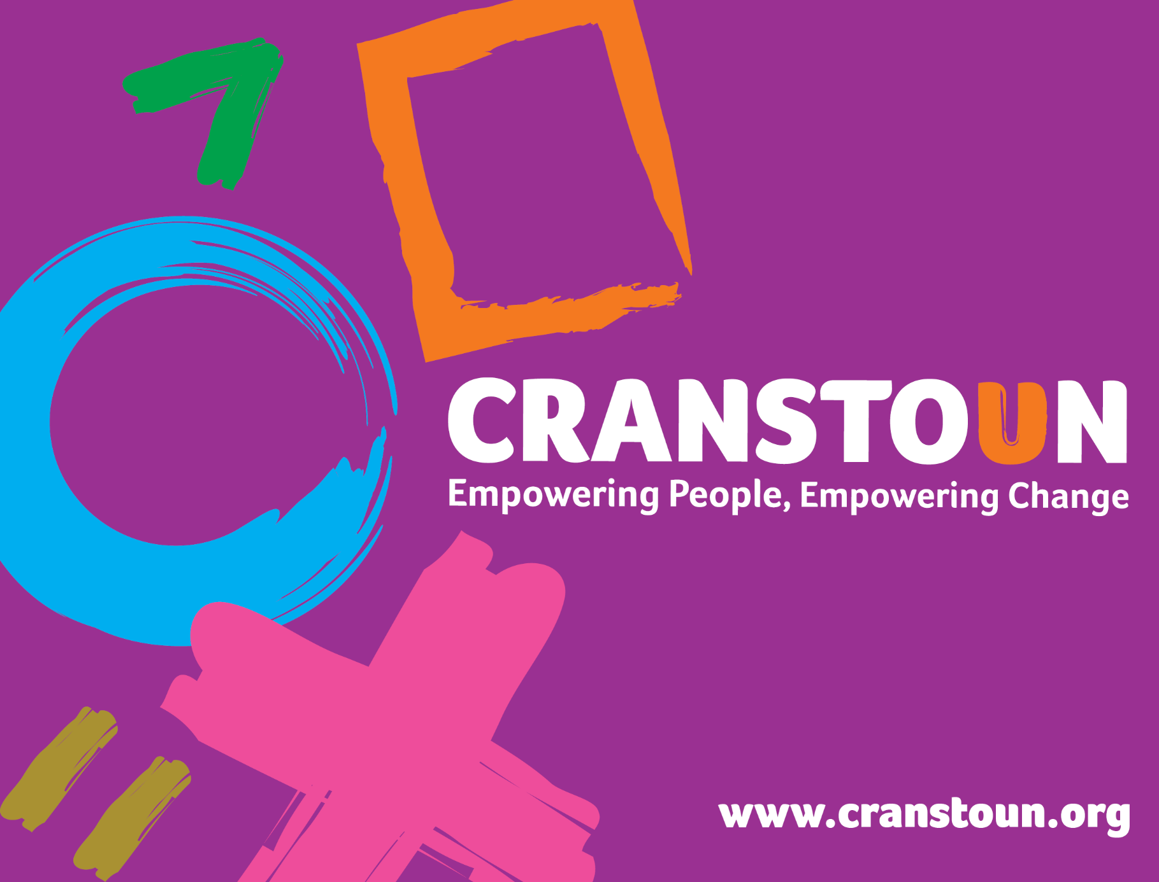

Post Information Pack: Key Worker (Outreach and Engagement)

Service | Cranstoun Worcestershire
Location | Worcestershire

Cranstoun is a social justice and harm reduction charity with global ambition.
Our Vision: To be a world-class leader in rebuilding lives.
Our Purpose: To inspire and empower people to live healthier and safer lives.
Our Values: Ambitious, Creative, Compassionate, Collaborative, Respectful.

Job Description
Job purpose / context:

- To provide a high-quality service to individuals presenting or in need, who have a history of alcohol and/or other drug related problems. This includes holding a caseload and associated activities.
- Deliver harm reduction interventions to ensure that the people who use our services reduce the risk from their alcohol and/or drug use.
- The role involves working in a trauma informed approach, providing advice, advocacy, a range of psychosocial interventions and support to individuals who have a history of alcohol and/or other drug use.
- Work in close partnership with other agencies to ensure individuals access a full range of services.

Responsible to:
Outreach and Engagement Nurse

1. Duties and Responsibilities:

- Work directly with individual’s using a trauma informed approach and deliver interventions to support people accessing services.
- Support referrals into service using structured guidelines to provide support for continuity of care.
- Carry out triage and comprehensive assessments utilising Psychosocial Interventions and ITEP techniques to provide relevant interventions based upon assessment or need.
- Co-ordinate the individual’s care to enable them to access pharmacological interventions where required, including opiate substitute therapy or relapse prevention medication.
- Comply with policy and procedures in the monitoring and management of an individual’s prescribing to ensure safe delivery of interventions.
- Undertake outreach and satellite provision, including, where relevant, the delivery of surgery based Shared Care and other locality based provision, to ensure the service covers the geographical region.
- Provide and deliver harm reduction advice, interventions, risk management and care plans including delivery of the service’s needle syringe programme, Blood Borne Virus screening.
- Identify safeguarding issues and respond appropriately using local authority and national guidelines.
- Assist those who use our services to explore and plan for future employment, training and education opportunities, linking with relevant local employment services where possible e.g. IPS
- Be involved or lead on the planning and facilitation of Group Work.
- Support and encourage peer support and access to mutual aid.
- Participate in and plan training for other professionals/groups.
- Provide written and verbal reports as requested by any member of the leadership team.
- Comply with all Cranstoun policies & procedures and encourage the same behaviours in others.
- Carry out other duties which you are deemed competent to perform as directed by your manager.
2. Advice & Information:
- Raise awareness about alcohol and other drugs, their use and effects.
- Be aware of current national policy directing and supporting drug and alcohol services.
- Positively promote Cranstoun with outside agencies and community partners.
- Enable individuals to adopt safer practice associated with alcohol and other drug use through effective communication of harm reduction as appropriate.
- Support individuals to understand and manage interactions between alcohol and other drug use and other forms of risk-taking behaviour such as sex, gambling, domestic abuse, self-harm.
3. Assessment & Care Planning
- Plan and agree service responses which meet individuals’ identified needs and circumstances and are in line with both service and national guidelines.
- Provide a warm welcome to those using the service, their families, carers and referrers using a trauma informed approach.
- Assist in the transfer of individuals between agencies and services
- Ensure a thorough assessment of need ongoing through an individual’s treatment journey and ongoing throughout their time in service, linking to all necessary teams and services such as primary care.
- Carry a caseload of individuals and provide and co-ordinate interventions appropriate to their needs.
4. Support
- Support individuals to access and use services and facilities.
- Support individuals who use alcohol and/or other drugs.
- Enable individuals to manage their financial affairs by using tools such as budgeting apps and refer to local services as required.
- Work with individuals to address their alcohol and/or other drug use using recognised models.
- Help individuals to address their alcohol and/or other drug use through an individualised Care Plan.
- Where appropriate, co-ordinate access to structured detoxifications, completing the necessary preparatory work to enable this to be delivered successfully and safely.
5. Monitoring
- Provide information which can be used to influence services design and identify unmet need and support decision making.
- Ensure records are kept up to date and relevant via the case management system.
- Use the review framework to ensure that individual reviews are adhered to, and all systems are updated.
- Complete all relevant documentation (e.g. TOP), for those in structured services.
- Ensure all clinical records are current and recorded electronically.
- Maintain records adhering to good Information Governance and in line with organisational and local policies and guidelines.
- Take an active role in team meetings and one to one meeting’ that positively address performance, monitoring and overall service responsibilities.

6. General – Professional Practice
- Relate to and interact with individuals and treat everyone with dignity and respect.
- Promote people’s equality, diversity, and rights.
- Promote choice, wellbeing, inclusion and the protection of individuals.
- Champion, promote, and live by the Cranstoun Values.
- Assess and act upon immediate risks of danger from alcohol and/or other drugs and other behaviours.
- Take personal responsibility for developing your own knowledge, practice and skills.
- Engage with supervision systems.
- Promote a collaborative approach to delivering the service with individuals, encouraging active involvement.

7. Operational Duties
- Contribute to maintaining a place of safety for staff and all those using the service.
- Maintain records as appropriate and in line with Cranstoun Polices and those of the service.
- Report through the line management structure as and when required in respect of client work.
- Liaise with all referral and partnership agencies and workers as and when appropriate.
- Maintain monitoring procedures as per policies.
- Provide information, advice and advocacy services to people who use our services
- Write reports on an individual’s progress to courts etc. in agreement with line manager
- Attend internal and external meetings and training as identified.
- Contribute to the development of services and policies.
- Provide relevant services in line with agreed targets and objectives.
- Undertake any additional duties as may be reasonably required by the Team Leader or Operational Manager.

8. Other Duties
Key Workers may hold a specific specialism as part of their role and may be required to demonstrate the following key activities and responsibilities:

Criminal Justice Interventions
- Work within a criminal justice setting to provide interventions to individuals with alcohol and/or other drug problems.
- Management of a caseload of individuals subject to court ordered treatment, Integrated Offender Management arrangements and other National Probation Service initiatives such as rehabilitation activity requirements.
- Respond assertively to track and keep contact with individuals within the criminal justice system including community, court appearances and prison releases.
- Support the delivery of Arrest Referral services including completion of Required Assessments.
- Identify individuals who may be suitable for court ordered treatment such as Drug Rehabilitation Requirements.
- Co-locate with criminal justice agencies in the delivery of the service where appropriate and possible.
- Hold experience of working alongside Probation services and the Police.
- Effectively co-ordinate the transfer of treatment care from prisons and provide ongoing case management.

Family Safeguarding Workers
- Work alongside Social Work teams within the Local Authority Children and Families team, coordinating appropriate levels of intervention and treatment to improve outcomes.
- Input into plans for Children in Need and Children in Need of Protection including immediate safeguarding interventions.
- Utilise psychosocial interventions in both one-to-one and group settings to promote engagement, enhance self-esteem, wellbeing and improve parenting capacity.
- Work with the family and other professionals to assess and identify individual’s needs.
- Create, contribute and implement a purposeful and meaningful care plan, which is recorded accurately and reviewed regularly in a collaborative way.
- Ensure all data objectives are achieved within agreed timeframes, working alongside Cranstoun managers and the Council commissioned Children and Families team to guarantee outcomes are achieved within defined statutory timeframes.

Outreach & Engagement
- Proactively engage individuals experiencing or at risk of homelessness to deliver outreach based harm reduction interventions, injecting equipment and naloxone provision, reducing the risk of drug and alcohol related harm.
- Identify barriers to entry into services and support to address these.
- Build rapport and confidence with people who are/or at risk of homelessness to enter into and maintain engagement with the drug and alcohol treatment service.
- Work in partnership with the Cranstoun Outreach and Engagement Nurse, mental health representatives, primary and secondary care, local authority and social care services, Homelessness agencies and those with lived/living experience to improve joint working and health outcomes for people who are/or at risk of homelessness.
- Attend and input into relevant multiagency meetings or forums that support engagement of people experiencing or at risk of homelessness.
- Provide advocacy for people experiencing or at risk of homelessness to support access to partnership services.
- Undertake outreach and satellite provision.

Person Specification

Qualifications & Experience

- Professional qualification in alcohol and/or other drug use, social work, Level 3 diploma in Health & Social Care.
- Experience of directly working with people who have alcohol and/or other drug issues or a comparable group.
- Ability to facilitate groups.
- Experience of using assessment tools.
- Experience of one-to-one work.
- An understanding of the needs of drug and/or alcohol users and knowledge of harm reduction.

Abilities and attributes

- The ability to work in a pressurised, multi-disciplinary environment.
- Good written and verbal communication skills with a good level of IT skills.
- Effective listening skills.
- Ability to work effectively and efficiently within a team and build effective working relationships with other agencies.
- A non-judgemental attitude to those who use alcohol and/or other drugs.
- Ability to organise own workload with minimal supervision.
- A shared sense of Cranstoun’s values; Ambition, Creativity, Compassion, Collaboration and Respect.
- Ability to undertake and develop a lead area as agreed with supervisor or line manager
- Willingness and ability to travel across the geographical service area independently.

Skills & Knowledge

- Knowledge of the range of community drug and alcohol services and models of treatment is desirable
- Knowledge of co-occurring conditions is desirable
- Word processing skills and knowledge of Microsoft packages.

Other

- Ability to travel independently and efficiently – access to your own transport would be desirable.

