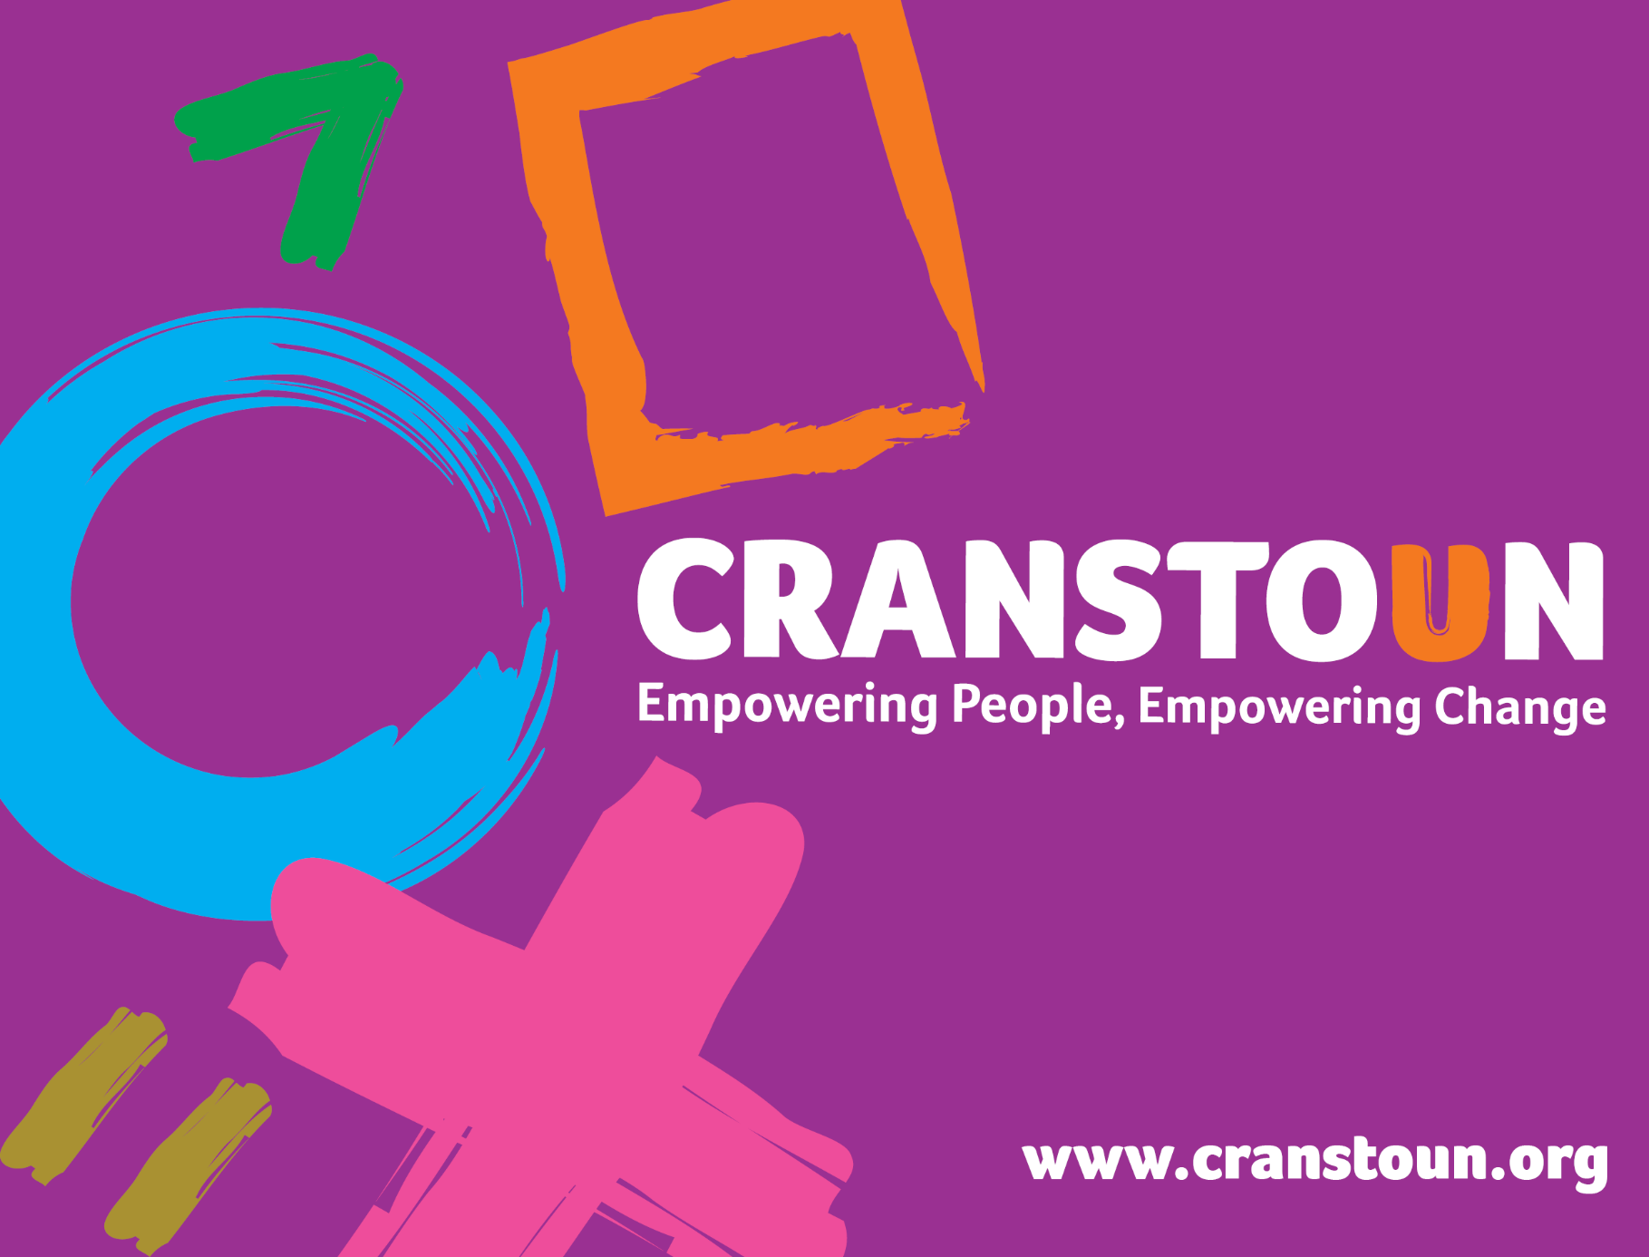

Post Information Pack
Keyworker

Service | Cranstoun Sandwell
Location | Sandwell

Cranstoun is a social justice and harm reduction charity with global ambition.
Vision: To be a world-class leader in rebuilding lives.
Purpose: To inspire and empower people to live healthier and safer lives.
Values: Ambitious, Creative, Compassionate, Collaborative, Respectful.
Job description
Job purpose / context:
- To provide a high-quality support to service users presenting or in need, which have a history of alcohol and other drug related problems by supporting a caseload of service users and associated activities.
- Working in a trauma informed approach, provide advice, advocacy and support to service users who have a history of problematic substance or alcohol use.
- Work in close partnership with other agencies to ensure service users access a full range of services.

Responsible to:
Team Leader

1. Duties and Responsibilities:

- Work directly with service users with a trauma informed approach and deliver interventions to support service users accessing services.
- Support referral into service using structured guidelines to provide support for continuity of care.
- Carry out triage and comprehensive assessments utilising Psychosocial Interventions and ITEP techniques to provide relevant interventions based upon assessment or need.
- Co-ordinate the client’s care to enable them to access pharmacological interventions where required, including opiate substitute therapy or relapse prevention medication
- Comply with policy and procedures in the monitoring and management of client prescribing to ensure safe delivery of interventions
- Undertake outreach and satellite provision, to ensure the service covers the geographical area sufficiently.
- Complete harm reduction advice, brief interventions, risk management and care plans
- Complete harm reduction interventions including but not limited to delivery of the service’s needle syringe programme, Blood Borne Virus screening
- Identify safeguarding issues and respond appropriately using local authority and national guidelines
- Assisting individuals to explore and plan for future employment, training and education opportunities and assist service users in relation to their aftercare
- Facilitate, plan and organise Group Work
- Support and encourage peer support and access to mutual aid
- Participate in and plan training for other professionals/groups.
- Provide written and verbal reports as requested by the Team Leader, Senior Practitioner or Borough Manager
- Comply with all Cranstoun policies and procedures.
- Carry out duties which you are deemed competent to perform as directed by the Borough Manager, Senior Practitioner or Team Leader

2. Advice & Information:
- Raise awareness about substances and alcohol, their use and effects
- Be aware of current national policy directing and supporting alcohol and other drug services
- Positively promote the Service throughout the borough
- Enable individuals to adopt safe practises associated with substance and alcohol use through effective communication of harm reduction as appropriate.
- Raise awareness about the use and effects of alcohol and substances and other risky behaviours
- Support service users to understand and manage interactions between substance and alcohol misuse and other forms of risk taking behaviour such as sex, gambling, domestic violence, self-harm and so on
3. Assessment & Care Planning
- Plan and agree responses which meet individuals identified needs and circumstances and are in line with both service and national guidelines
- Provide a warm welcome to new services users, their families, carers and referrers using a trauma informed approach
- Assist in the transfer of individuals between agencies and services
- Carry a caseload of individual service users and provide and co-ordinate interventions appropriate to their needs.

4. Support
- Support individuals to access and use services and facilities.
- Support individuals who are substance and/or alcohol users
- Enable and signpost individuals to manage their financial affairs
- Work with individuals to address their substance and/or alcohol use using recognised models
- Help individuals address their substance and/or use through an individualised Care Plan
- Where appropriate, co-ordinate access to structured detoxifications, completing the necessary preparatory work to enable this to be successful and delivered safely

5. Monitoring
- Provide information to support decision making
- Ensure records are kept up to date and relevant via the digital database
- We are a paperless service therefore all documents must be scanned on to the records
- Use the review framework to ensure that the minimum 3 monthly reviews are adhered to and all paperwork is completed
- Complete all TOPS/Stars for service users in structured services
- Ensure all clinical records are current and recorded electronically
- Maintain records as adhering to good information Governance & in line with Cranstoun and service’s local policies and guidelines

6. General – Professional Practice
- Relate to and interact with individuals.
- Promote peoples equality, diversity and rights
- Promote choice, wellbeing and the protection of individuals.
- Assess and act upon immediate risk of danger to or from substance and/or users.
- Develop your own knowledge and practice
- Make use of supervision
- Promote the collaborative approach to delivering the service with service users, encouraging active service user involvement

7. Operational Duties
- Contribute to maintaining a place of safety for all service users & staff
- Maintain records as appropriate & in line with Cranstoun Polices and those of the service
- Report to the Team Leader as & when required in respect of client work.
- Liaise with all referral and partnership agencies and workers as and when appropriate.
- Maintain monitoring procedures as per policies
- Provide information, advice and advocacy services to service users as required
- Write reports on client progress to courts etc. as and when required
- Attend internal and external meetings and training as required.
- Contribute to the development of services and policies.
- Provide relevant services in line with agreed targets and objectives
- Undertake any additional duties as may be reasonably required by the Team Leader, Senior Practitioner or Borough Manager.

8. Other Duties
- Develop productive working relationships in service and across all partnerships
- Agree co-working arrangements and liaise with Primary and Secondary Care Health teams including mental health services, Care Managers, Children and Adult social care services, Police, Probation Officers, Peer Support Services and other key agencies concerned with the client.

Person specification

Qualifications & Experience
- Professional qualification in substance or alcohol misuse, social work, NVQ, Level 3 in Health & Social Care
- Experience of direct client work with substance use and/or alcohol issues or a comparable client group.
- Ability to Facilitate Groups
- Experience of using assessment tools
- Experience of one-to-one work
- An understanding of the needs of substance and alcohol users and knowledge of harm reduction.
- Experience and understanding of the importance of 1-2-1 Supervision/performance reviews.
- Evidence of professional/clinical knowledge gained through continuous professional development evidenced by further training/additional qualifications.

Skills
- The ability to work in a pressurised, multi-disciplinary environment
- Good written and verbal communication skills with a good level of IT skills.
- Effective listening skills
- Ability to work effectively and efficiently within a team and build effective working relationships with other agencies.
- A non-judgemental attitude to all people including substance and alcohol users
- An understanding of care planning and risk management
- Ability to organise own workload with minimal supervision.
- Ability to undertake and develop a lead area as agreed with supervisor or line manager

Communication
- Clear and accurate oral and written communications.
- Able to communicate confidently and effectively with a range of stakeholders and professionals
- Well-developed communication skills with the ability to influence and persuade key personnel to improve practice.
- Is open and shares ideas and knowledge.
- Shows respect for others
- Ability to communicate messages and engage fully with people
- Set clear boundaries across all relationships
- Adopt a person-centred focus to communication.

Team Work
- Participate and collaborate with internal and external teams.
- Liaise with other agencies to support service users.
- Ability to lead by example and demonstrate team work

Problem Solving
- Identify and be alert to risk; manage contingency plans effectively.
- Ability to learn and apply theoretical knowledge in practical situations.
- Show creativity and innovation
- Ability to make critical decisions in a timely, considered manner.

Attention to Detail
- Maintain confidentiality of all data and information related to service users and business.
- Ability to manage own time, prioritise activities and maintain accountability for workload and service users.
- Accurate record keeping and an understanding of the importance of this across the service
- Ability to work non-judgementally.
- Awareness of range of cultural differences.

IT
- Excellent keyboard skills and excellent ability to use a data management system.
- Good IT skills and the ability to use MS Office (Outlook, Word, Excel, PowerPoint).

Other
- Willingness and desire to work in an environment of continual change.
- Proactive engagement with change and progressive concepts, with an openness to learn.
- A flexible approach to working hours and location including a late evening and weekends where required.
- Able to travel independently, in a timely manner, within work area.

