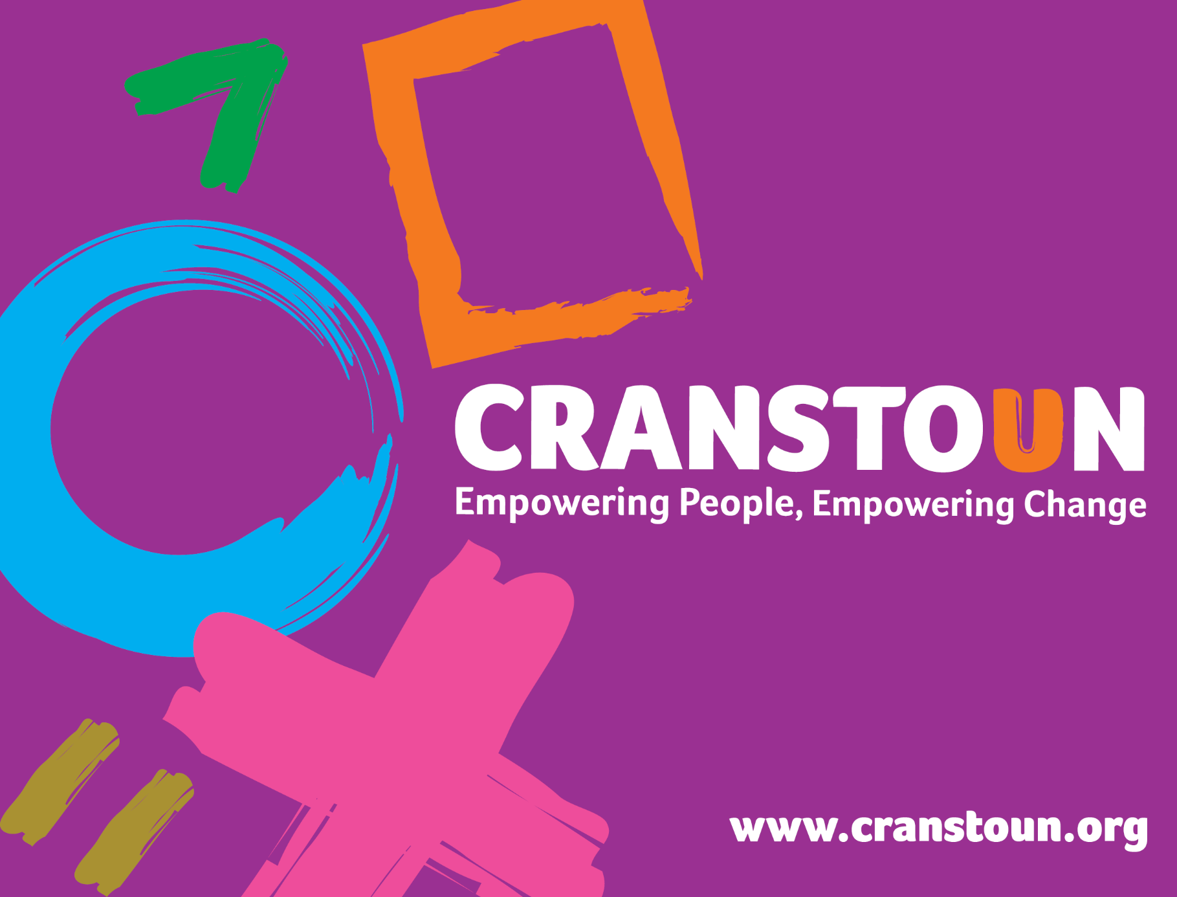

Post Information Pack
Young People’s Substance Use Worker

Service | Here4YOUth Oxfordshire
Location | Oxfordshire

Cranstoun is a social justice and harm reduction charity with global ambition.
Vision: To be a world-class leader in rebuilding lives.
Purpose: To inspire and empower people to live healthier and safer lives.
Values: Ambitious, Creative, Compassionate, Collaborative, Respectful.

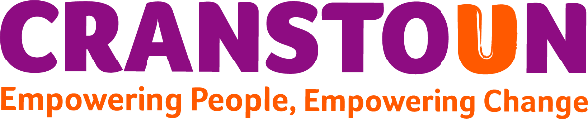
Job description
Job purpose / context:

- To carry a case load of young people, working in a trauma informed approach to provide specialist assessment, care planning, brief, structured or comprehensive interventions around alcohol and other drugs
- To build the resilience and coping skills of children and young people whose parents or other family members using drugs or alcohol
- To contribute to reducing the negative impacts of drugs and alcohol on children and young people’s educational achievement, longer term employment prospects and their overall health and wellbeing
- Deliver evidence based psychosocial and educational interventions, taking a whole family approach, providing support to young people as a result of familial substance use
- Gather and complete mandatory data collection to report to National Drug Treatment Monitoring Service
- To work closely with targeted youth support teams and other partners including Oxfordshire children and family centres to achieve the best outcomes
- To engage with young people and their families in various settings such as children and family centres, drop-ins, schools, colleges, and homes and local community venues
- Be pro-active with service user engagement, providing opportunities for young people to make decisions, have a say and influence/shape their care and service delivery
- To work flexibly to meet the needs of young person and their families of Oxfordshire

Responsible to:
Team Leader/Service Manager

Responsible for:

- Key clients and activities

- To build relationships quickly with young people promoting a safe and trusting environment
- Work flexibly to meet the needs of young people and families across Oxfordshire. Providing a blended offer of face to face appointments and online
- Have a presence at appropriate school, college, and community events to promote Cranstoun Here4YOUth and provide initial information and advice
- Promote and deliver targeted campaigns as appropriate, including across social media
- Provide young people and their families with advice, information and help to access practical support for the things that may be contributing to their substance use
- To carry out a detailed substance use assessment, utilising ITEP mapping and motivational interviewing skills assessing the impact of their/parental substance use on social functioning and wellbeing
- Utilise audits in the assessment to identify the correct treatment pathway for the young person i,e Brief, structured or comprehensive
- Support and co-ordinate young people’s care to enable them to access pharmacological interventions if required
- To contribute to reducing the transmission and spread of blood borne viruses associated with drug use
- To contribute to reducing sexually transmitted diseases and teenage pregnancy by reducing risky behaviours related to drug and alcohol use.
- Work in a holistic way, discuss, agree and review care plans, ensuring wider needs are met
- To appropriately include parents/carers and other professionals in the care planning and delivery of support for the young person
- Work effectively with partner agencies to deliver a quality service, focussed on achieving positive change
- To contribute to reducing crime, anti-social behaviour and the exploitation of children and young people that is associated with the use of drugs or alcohol including delivering Divert sessions
- Ensure risk is assessed appropriately and dynamically with a management plan agreed where necessary
- Ensure safeguarding needs of young people are assessed, monitored and actioned according to guidelines and good practice, working closely with Oxfordshire’s children’s social care teams as required
- Help to protect individuals and families from harm by attending, contributing and honouring responsibilities connected to multi-agency meetings
- Deliver effective evidenced-based interventions which enable young people to make positive changes, increase resilience and improve outcomes. This will include both individual and group-based client work delivering structured intervention programmes face to face and online
- Deliver interventions within a harm reduction approach to reduce risks, whilst developing resilience
- Support children and young people whose parent(s) use or have used alcohol and/or other drugs. Including facilitating group interventions, including the Moving Parents and Children Together (M-PACT) family group programme
- Facilitate both group and one to one life skill development, administering an AQA Unit Award Scheme to build the aspirations and confidence of children and young people
- Support the delivery of a high-quality service and the achievement of our contractual targets by staying up to date with best practice and initiatives, and taking on additional training, which will help to improve the lives of service users
- Ensure young people have a smooth transition with adult teams
- To take a lead role and additional training in key areas of expertise in order to best meet the needs of children and young people e.g. Hidden Harm, Overdose
- To attend and be actively involved in service meetings and supervision
- To contribute to reducing drug and alcohol A&E attendances, inpatient admissions and deaths related to substance use

- Team

- Assist in maintaining a place of safety for all clients and staff.
- Adhere to health and safety requirements
- Attend team meetings and other forums as required.
- Participate in supervision, support and training as agreed with line management.
- Provide, in conjunction with colleagues, staff cover across Oxfordshire
- Undertake responsibilities, and plan absence from the workplace, to maximise the effectiveness of quality service delivery.

- Administration

- To accurately maintain client management systems, accurately evidencing achievement of outcomes for young people
- Produce reports relating to clients and project work as required by the Service Manager, organisation and/or our partner agencies.
- Ensure all requirements for National Drug Treatment Monitoring Agency (NDTMS) are adhered to
- Ensure contractual targets are being achieved

- Projects

- Undertake liaison with all partner agencies as appropriate and required.
- Undertake appropriate liaison with other Cranstoun services and workers.
- Actively participate in the delivery of ‘ROAD’
- Actively support the development of Cranstoun Here4YOUth youth ambassador and lived experience

- Other

- Adhere to the policies and procedures of Cranstoun
- Adhere to the terms and conditions of employment as agreed with Cranstoun
- Undertake any additional duties as may be reasonably required from time to time by the team leader and Service Manager or Organisation.
- Ability to work flexibly to meet the needs of young people

Person specification

Experience

- Experience of direct and focused client work with vulnerable young people who use alcohol and other drugs
- Experience of using strengths-based assessment tools and interventions
- Experience of completing and reviewing care plans and risk assessments
- Experience of community engagement
- Experience of delivering group work
- Experience of working on MS teams
- Experience of young people’s safeguarding

Abilities and attributes

- Ability to work effectively and efficiently both independently and as part of a team
- Ability to liaise with and build effective working relationships with other agencies
- Ability to deliver group work programmes
- Ability to maintain accurate and up to date records in line with guidance
- Ability to engage with and motivate young people who may be ambivalent by providing a range of interventions.
- Ability to maintain high standards of confidentiality, including safe and secure storage of confidential information
- Ability to work evenings and possibly weekends as necessary.
- Ability to work in formal and structured settings e.g. young people involved with children’s services, education and youth justice systems
- Ability to engage positively with young people and their families
- Ability to coordinate multi agency care planning, working with partners to deliver a holistic programme of interventions tailored to the individual
- Empathy for our particular client group

Skills

- Good written and verbal communication / reporting skills
- Willingness and ability to develop Information Technology skills and to undertake administrative tasks.
- Commitment to Equal Opportunities in employment and service delivery, to clients’ rights and the delivery of quality services.
- Effective engagement and communication skills with young people
- Multi agency working including confidentiality and shared care arrangements

Knowledge

- An understanding and knowledge of harm reduction appropriate to young people.
- Understand the purpose of alcohol & other drugs assessment including outcome measures and data
- Knowledge of the legislative framework for working with young people including issues of safeguarding, child protection, consent and confidentiality.
- Experience of and understanding of working with young people from Black and Ethnic communities.
- Child and young person development
- The safeguarding, promotion and protection of the rights, welfare and safety of young people

Liaison and partnership

- Ability to work effectively and efficiently within a team
- Ability to meet targets & deadlines
- Ability to build effective working relationships with partnership agencies
- Ability to advocate on behalf of young people and families

