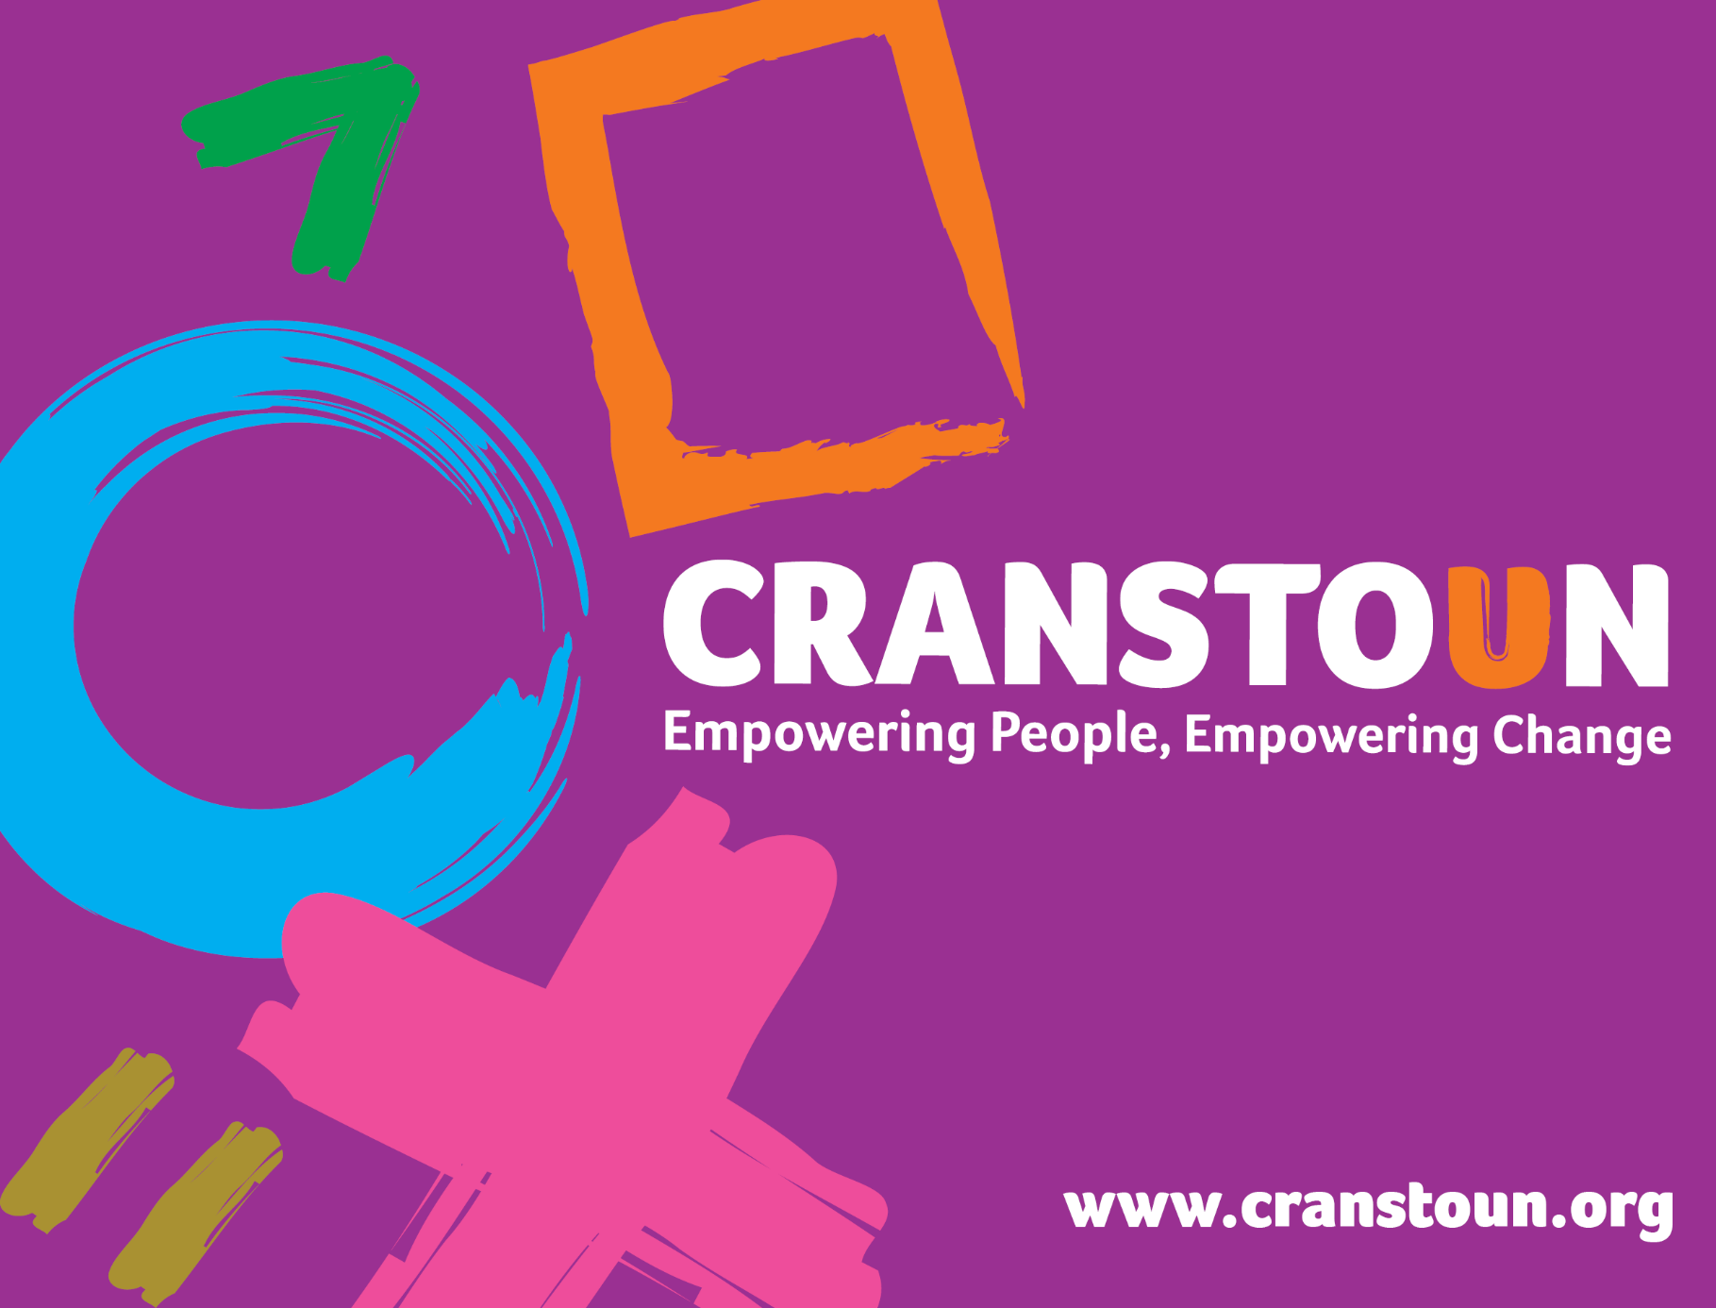

Post Information Pack
Housing Support Worker

Service | Wandsworth Supported Housing
Location | Wandsworth

Cranstoun is a social justice and harm reduction charity with global ambition.
Vision: To be a world-class leader in rebuilding lives.
Purpose: To inspire and empower people to live healthier and safer lives.
Values: Ambitious, Creative, Compassionate, Collaborative, Respectful.


JOB DESCRIPTION

Job purpose / Context:

Cranstoun manage 5 supported housing services accommodating 30 service users in the borough of Wandsworth, forming one housing pathway. Our service provides accommodation to individuals who use drugs/alcohol. West Hill is the first stage for high support service users who are rough sleepers or at risk of rough sleeping and can move within the pathway as their needs change. We also have a floating support service for when residents move onto independent living within Wandsworth, to support them with this transition.

The Housing Support Worker role is part of a team that delivers a high quality service to people living within the high tolerance supported housing at West Hill to help them thrive by addressing their substance use using a harm reduction approach.

The work involves working on a rota which includes weekend work.

Responsible to:

Team Leader / Service Manager

- Resident Services
- Treat all residents with compassion and respect, identifying their talents and aspirations and support them to achieve them
- Engage residents effectively by establishing a trusting working relationship which is person-centred and empowering.
- Provide practical, flexible and personal support to residents in an approachable, caring and person-centred way.
- Use Outcomes Star to agree and monitor support and personal goals
- Undertake comprehensive assessments of residents’ strengths and risks, including risk management plans
- Make referrals and link people in with relevant services such as health and community services.
- Work closely with the local treatment service and keep up to date with their service offer, access and interventions.
- Provide harm reduction support and advice with regards to substance use.
- Respond to emerging issues from all residents
- Process admissions and exits to and from the service
- Lead and coordinate the support for allocated residents
- Ensure residents have access to income and are supported to claim any benefit entitlement where applicable (including housing benefit)
- Facilitate active resident involvement within the service, seeking, encouraging and acting on their feedback to improve service delivery
- Participate in the running of a group life skills programme, enabling residents to identify and build their confidence and abilities.
- Undertake activities with the residents, including preparing breakfast with/for all residents
- Support the development of resident’s self-esteem and skills so that they can become as independent as possible.
- Taper support as confidence grows, and residents progress through the housing pathway.
- Assist in the monitoring, evaluation and processing of all referrals to the service
- Advocacy
- Work on a rota covering early and late shifts as well as sleep-ins. Sleep ins due to start 2024.

- Housing Management
- Deal with referrals and sign up licensees, explaining
- Get rooms ready for re-letting including preparation/cleaning of rooms
- Monitor rent arrears and collect rent from residents
- Keep local rent accounts up to date and apply rent collection procedures.
- Complete housing benefit claims
- Deal with anti-social behaviour and resident conflict
- Carry out building checks including room checks, health and safety checks COSHH monitoring.
- Report & record repairs, facilitating contractor access
- Test of fire alarms, check extinguishers, emergency lights, fire doors, water temperature testing, fire drills
- Tenancy sustainment: manage and support residents in adhering to the conditions of their licence agreement
- Supporting people to move through the pathway and/or find accommodation in the community
- Ensure the communal areas of the project are clean and tidy

- Project / Team
- Working as part of a team responsible for the day to day management of the project. Working alongside residents, assist in maintaining a high quality positive, safe and secure environment for all residents to live and people to work in.
- Assist with keeping the service clean and tidy, ensuring a positive, welcoming and inspiring environment is provided for all residents
- Adhere to health and safety requirements and conduct health & safety checks, including fire checks and water temperature testing
- Participate within team meetings and other forums as required to continuously improve service delivery.
- Work at other service sites as and when required.
- Participate in staff supervision, support and training as agreed with your line manager.
- Undertake responsibilities, and plan absence from the workplace, to maximise the effectiveness of quality service delivery.

- Administration
- Assist in the maintenance of accurate records relating to service finances such as petty cash
- Maintain accurate and appropriate resident records on our case management system
- Produce reports relating to resident progress and housing management activities as required from time to time
- Assist in data collection and report writing

- Collaboration
- Work in partnership with key referral agencies to support residents throughout the moving in/out process
- Work closely with Wandsworth substance use treatment team who will be coming into the service to deliver effective support and treatment to residents of the service, maximising their opportunity to reduce harmful behaviours in relation to substance use.
- Work in partnership with a range of external professional agencies and workers to connect residents into a range of opportunities and resources.
- Work jointly with the Hestia floating support service to ensure effective move on support for residents.
- Undertake appropriate liaison with other Cranstoun services and workers.

- Other
- Adhere to the policies and procedures of Cranstoun
- Adhere to the terms and conditions of employment as agreed with Cranstoun.
- Undertake any additional duties as may be reasonably required from time to time by the Service Manager /organisation
PERSON SPECIFICATION
Experience

- Experience of direct work with people who are drug/alcohol users, those who are homeless, or a comparable service user group.
- Ability to assess peoples’ needs and supervise their support plan from referral to exit
- Experience of one to one work and group work
- Commitment to Equal Opportunity in service delivery and a commitment to people’s rights
- Experience of using assessment and support planning tools

Abilities and Attributes

- Ability to work equally with the strengths of each individual as well as the risks.
- Ability to organise daily routine, undertake informal work and motivate people in a range of activities
- Ability to work effectively and efficiently within a team
- The ability to collaborate with and build effective working relationships with other agencies.
- A non-judgemental attitude to drug/alcohol users and those at risk of homelessness
- Cultural awareness
- Commitment to the rights of people to determine their own choices.
- Ability to deliver a high quality service and to involve residents, acting on their feedback
- Ability to meet targets & deadlines
- Initiative & diplomacy
- Maintain clear professional boundaries

Skills

- Good written and strong verbal communication skills
- Excellent listening skills
- High standard of IT skills and ability to use MS Office (Word, Excel, Outlook)

Knowledge

- An understanding of the needs of drug/alcohol users and knowledge of harm minimisation.
- Knowledge of dual diagnosis and homeless legislation
- Knowledge of the range of community drug services and models of treatment
- Knowledge of brief intervention methods and motivational interviewing
- Desirable Health & Social Care Level 3

Qualifications

- Qualification or demonstrable relevant experience at NVQ level 3 in Health and Social Care preferred but not essential

