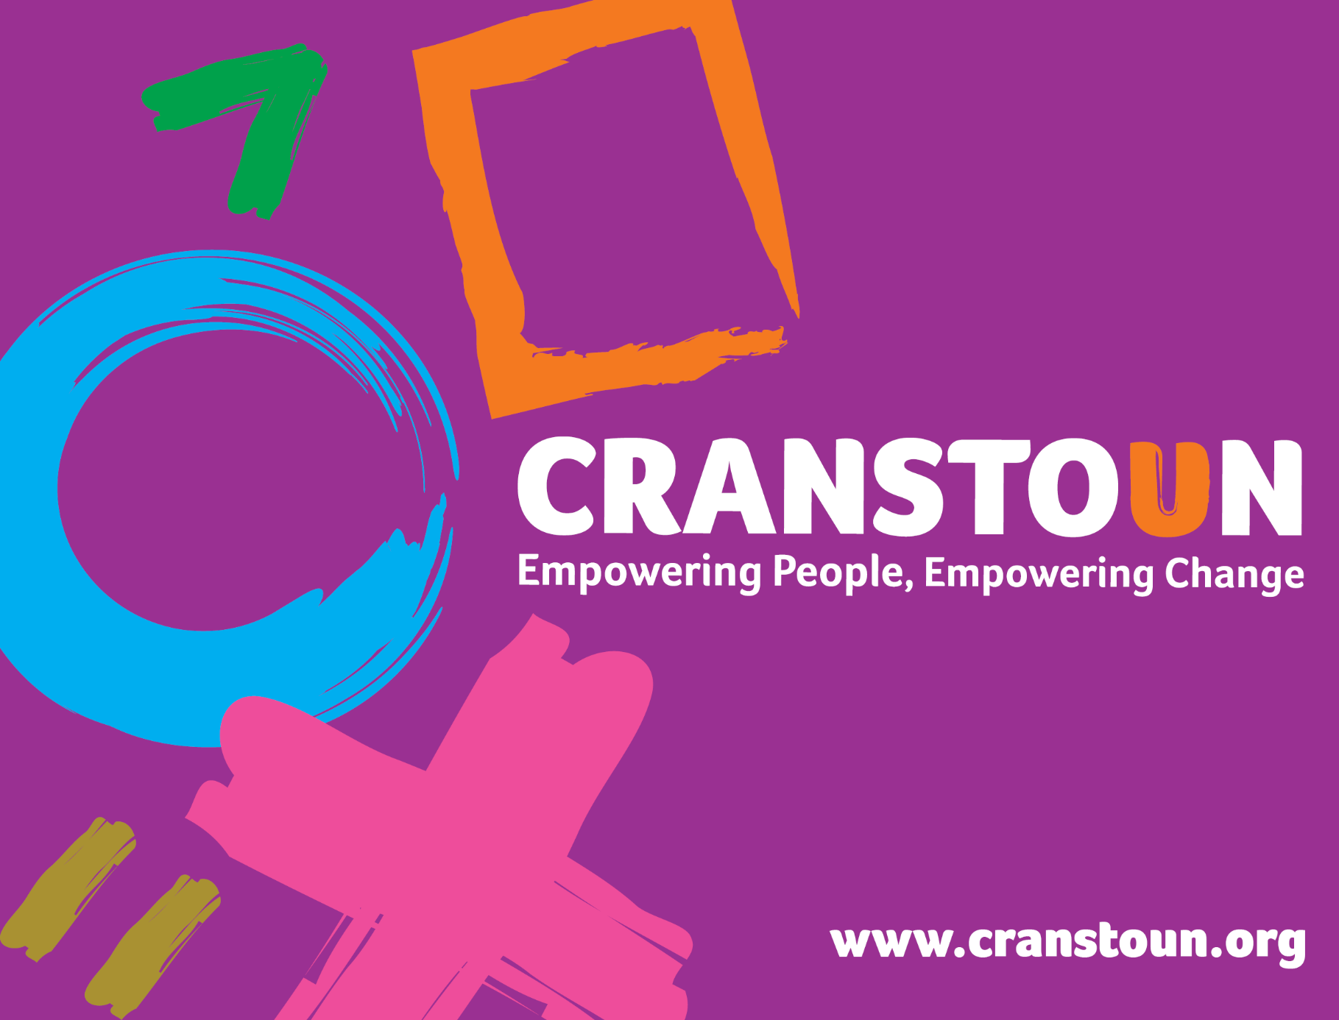

Post Information Pack
Drive Case Manager

Service | The Drive Project
Location | West Mercia – Shropshire, Telford & Wrekin

Cranstoun is a social justice and harm reduction charity with global ambition.
Vision: To be a world-class leader in rebuilding lives.
Purpose: To inspire and empower people to live healthier and safer lives.
Values: Ambitious, Creative, Compassionate, Collaborative, Respectful.


JOB DESCRIPTION

Job purpose / Context:

The case Manager will champion the Cranstoun values across the organisation and drive the Cranstoun 'people' agenda ensuring a culture based on fairness, collaboration and trust.

Drive is a high risk / high harm domestic abuse perpetration intervention. Its sole aim is to reduce the risk posed by those using high levels of harm towards family members and / or (ex) partners. This is achieved via disruption, diversion and direct behaviour change work, where safe to do so, within a multi-agency framework.

The Case Manager will strive to work one-to-one with perpetrators who have been identified as high risk to pro-actively secure engagement, influence attitudinal and behavioural change and connect with complementary services. To do this, the Case Manager will work with local agencies to design a co-ordinated, strategic individual intervention plan to address identified needs and risks and promote understanding of the impact of abusive behaviours. However, it may not always be safe or possible to meet with the perpetrator. Equally as vital to risk reduction efforts is analysis of presenting information to identify ways to disrupt their abusive behaviour, alongside closeknit multiagency working to implement actions.

Throughout all intervention the Drive Case Manager will work closely with the local IDVA service to review risk, develop safety plans and improve outcomes for all parties involved.

The Case Manager will be responsible for delivering outcomes, working typically for up to 12 months to achieve behaviour change with each Service User.

As part of this role the Drive Case Manager is required to complete the OCNLR accredited level 3 Drive Case Managers qualification in Domestic Abuse: Prevention and Early Intervention. This is a fully funded opportunity to gain the essential skills and knowledge to perform the role.

Responsible to: Drive Service Team Leader

Responsibilities:
- Interagency Work

- Develop and maintain effective partnership working with statutory, private and voluntary agencies to address the issue of domestic abuse.
- Work to embed the Case Manager role into multi-agency responses to domestic abuse in the area.
- Work closing with other professionals to ensure that risk management and safeguarding duties are effectively met.
- Provide a single point of proactive and regular contact for a range of professionals involved in the case of the Service User.
- Support other professionals in responding to Service Users in a way that is coterminous with the aims and ethos of the Drive Project.
- Work closely with the IDVAs supporting the partners, ex-partners and new partners, and family members of Service Users in management of risk and developing intervention plans, as set out in the Drive Manual.
- Effective implementation of institutional advocacy through pro-socially challenging partner agencies, acknowledging best practice and striving for change to benefit the individual, the service and the sector.
- Represent the service at operational multi-agency meetings, feeding back initiatives and outcomes to the team and contribute to the evaluation of the quality of activities these services offer.

- Case Management

- Manage a case load focusing on high-risk perpetrators of domestic abuse to provide an assertive, medium to long term service, based on thorough assessment and individual support planning that adopts the principles of the ‘Support or/and Disrupt’ concept.
- Comply with safeguarding and information sharing policies, ensuring that Service Users and colleagues understand and comply with relevant safeguarding frameworks.
- Contribute to regular service reviews which include monitoring data, evaluations, intake and output policy, and practice and workload reviews for the whole service.
- Attend monthly case management meetings with the Service Manager.
- Attend clinical supervision.
- Recording and administration
- Ensure that case files and records are accurate and complete and are kept in compliance with data protection and information sharing legislation and protocols.
- Enter all the required information into the Drive project electronic case management system to enable tracking of Service User change, multi-agency working and risk management.

- Direct work with Service Users

- Maintain a proactive response to service users, continuously providing positive options for behaviour change throughout the service users time in the Drive project
- Use combination of motivational work, relationship building and a broad range of therapeutic skills to engage service users to addressing their abusive behaviour
- Motivate and support service users to address the broad range of needs that may contribute to the risk that they pose to others or act as barrier for them in addressing that risk. e.g. housing, substance use etc.
- To ensure that service users understand that the community and Drive project will ensure that they are accountable for continued use of abuse and abusive behaviour towards others
- Ensure that there is a consistent delivery of services to the identified perpetrators of domestic abuse, including comprehensive risk assessment, support planning, and referrals to multi agency panels including MARAC and DAPP.
- Develop strategies that will disrupt the continued risk posed by service users
- Undertake assessment of risk, needs and attitudes to inform the individual service user’s intervention plan
- Ensure that risk assessment and risk management procedures are followed at all times.
- Respect and value the diversity of the community in which the service works in, providing a service that recognises the diverse needs of service users and their families.
- Work closely with the IDVAs’ supporting the partners, ex-partners and new partners, and family members of service users in management risk and developing intervention plans, as set out in the Drive Manual.
- The welfare and safety of children and young people is paramount, considered in every aspect of your work, address parenting needs where appropriate and taking action to safeguard children.

- General

- Remain up-to-date and compliant with all relevant legislation connected to your work, including organisational procedures, policies and professional codes of conduct and practice guidance, in order to uphold standards of best practice.
- Represent the service at local events; deliver training and presentations as required.
- Feed into the learning process via the service to improve services for perpetrators of domestic abuse, ensuring that the experiences of Service Users and other agencies inform this process.
- Be confident to evidence reflective practice in all aspects of work.
- Be committed to reviewing individual and team practice and undertake regular training.
- Act with integrity and respect when interacting with Service Users, employees, agencies and individuals.
- Be competent in defensible decision making, recording and being held accountable.
- Show initiative in tackling issues within the service and in relation to other agencies.
- Act as a champion for the programme in your area.
- Hold a full driving license, have access to a car and able to travel across the area as required.
- Partake in evening and weekend work as required.
This job description is subject to review and revision, as agreed by the post holder and Director of operations in order to maintain a relevance to work undertaken and any changes to the demands of the internal or external environment.
PERSON SPECIFICATION

The post holder will have a demonstrable track record in the delivery of domestic abuse interventions and working as part of a multi disciplinary team. The post holder will also be a strong role model of the Cranstoun values: ambition for service users, compassion, innovation and integrity.

Experience: Essential

- Direct work with vulnerable Service Users.
- Working within a multi-agency public protection/safeguarding setting .e.g. Child protection, vulnerable adults, Marac, Mappa.
- Managing safeguarding issues and procedures.
- Writing and presenting information formally and informally, to a range of audiences.
- Working within legislative frameworks and using this application to develop, influence and encourage partnership working.
- Working within conflict management.
- Evidence of keeping reliable and timely reporting and meeting deadlines.

Experience: Desirable

- Work with victims and or perpetrators of domestic abuse.
- Work with Service Users with complex needs and/or challenging behaviour.
- Work with Service Users with diagnosed mental health issues.
- Work with Service Users with substance misuse.
- Work with young people aged 16-25 years.
- Using pro-social modelling and motivational interviewing in practice.

Abilities and attributes

- An ability to work collaboratively as part of a team; whilst also having the initiative and confidence to work independently as necessary.
- Flexible and available to work in all types of statutory and voluntary sector environments.
- Belief in perpetrator behaviour change.
- Proactive and self-motivated.
- Reflection and self-awareness skills.

Skills

- Competent IT skills, including use of Microsoft Office.
- Excellent communication skills (both written and oral)
- Hold a relevant degree, a vocational qualification or equivalent experience.
- Good relationship management with regard to multi-agency work that incorporates sensitivity, responsiveness and effective partnership working.
- Have excellent advisory, negotiation & persuasive skills to support and guide Service Users.
- Ability to lead and facilitate discussions to achieve a positive outcome.
- Excellent interpersonal skills and the ability to demonstrate empathy.
- Excellent crisis management skills and the ability to deal with stressful and difficult situations including conflict, challenge and trauma.

Knowledge

- Have an excellent understanding of domestic abuse, including the impact on victims and their children, and the legal and practical remedies available.
- Have a good knowledge of effective ways of working/engaging with perpetrators of domestic abuse.
- Have a thorough understanding of IDVA work including risk assessment, risk management and comprehensive safety planning.
- Have theoretical and procedural knowledge of other services and multi-agency partnerships involved in the response to domestic abuse, including Marac.
- Have an understanding of public protection arrangements, policing, child protection, health and social care, housing support and of multi-agency/partnership working.

