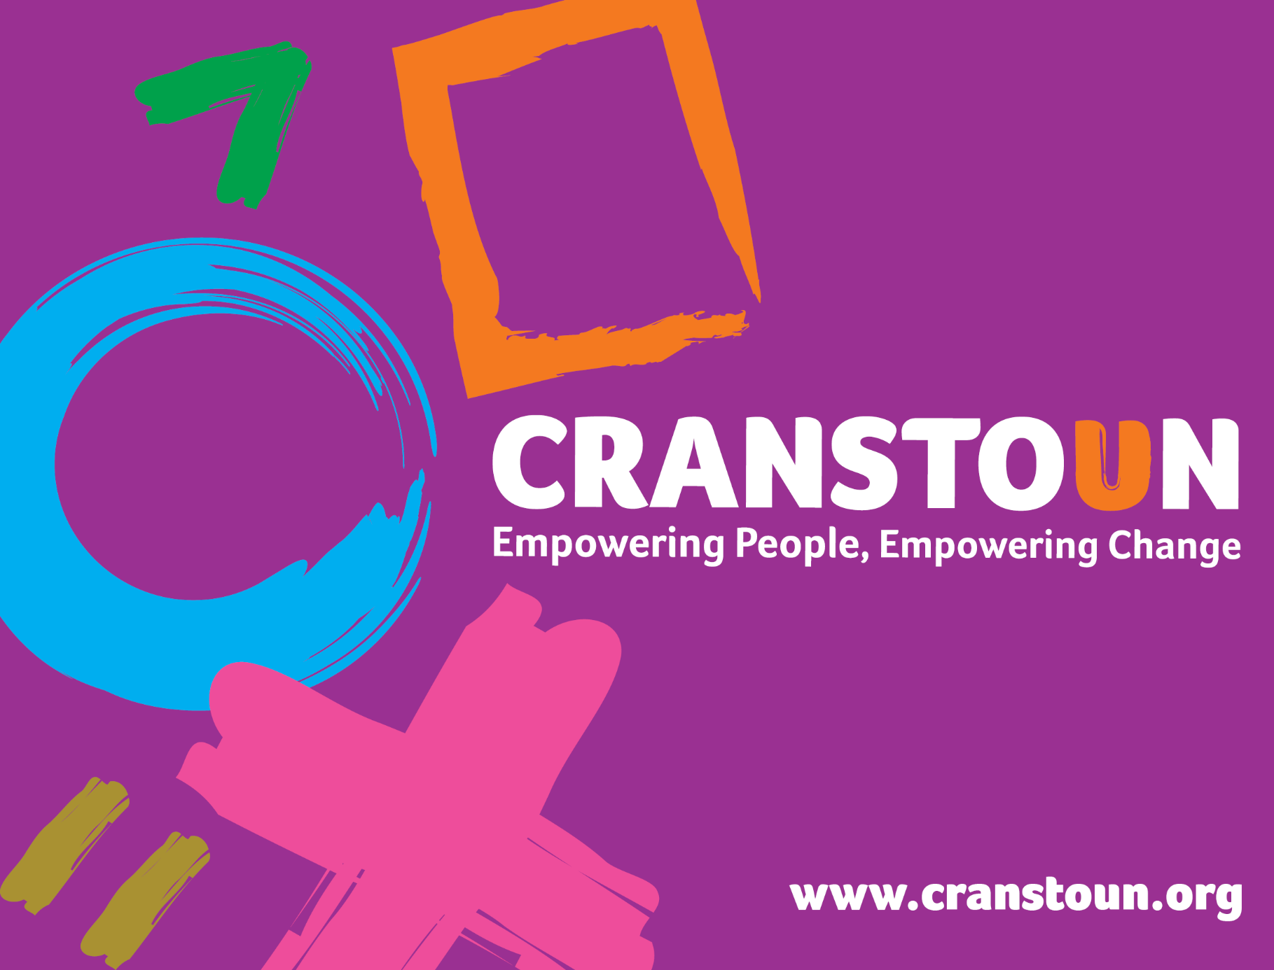

Post Information Pack
Healthcare Assistant

Service | Cranstoun
Location | Derby

Cranstoun is a social justice and harm reduction charity with global ambition.
Vision: To be a world-class leader in rebuilding lives.
Purpose: To inspire and empower people to live healthier and safer lives.
Values: Ambitious, Creative, Compassionate, Collaborative, Respectful.

Job description
Job purpose / context:
- To work flexibly within the service to provide a range of clinical interventions for people who use alcohol and other drugs. The role will include assessment of service users, blood borne virus screening, health screening, ambulatory detoxification delivery and support to team members in managing the health needs of people who use the Cranstoun Derby service.

Responsible to:
- Operations Manager and Clinical Lead

Responsible for:
- Provide a clinical support service to people who use alcohol and other drug users that meets their needs.
- Delivery of specific health interventions including general health assessments, screening (including taking and recording of basic observations), ECGs, detoxification programmes and venepuncture.
- Support other clinical staff with the delivery of effective and efficient clinical interventions to people accessing the treatment service, including ambulatory detoxification programmes.
- Develop alongside nurse prescribers and keyworkers, clinically safe and effective detoxification plans with individuals that are; comprehensive, person-centred and individualised.
- Completing accurate, person-centred and individualised risk assessments and risk management plans ensuring a high standard of documentation and due consideration for all safeguarding needs.
- Assist with wound care assessment and wound dressing in line with service and national guidelines.
- Where directed, support clinical team with the delivery and co-ordination of medical reviews and interventions in line with your competency.
- Promotion of health education and information on health and wellness, including the effects of drug and alcohol use and the importance of maintaining a healthy lifestyle.
- Ensure individuals accessing the service receive high quality harm reduction interventions (e.g. blood borne virus testing, safe alcohol reduction plans, Naloxone provision).
- Organise signposting to other services as required and ensure clear pathways into other health services as appropriate.
- Take all reasonable steps to ensure the safety of service users, relevant others (particularly children and vulnerable adults) and members of the community.
- Communicate effectively with service users and their carers, actively listening to understand their needs.
- Work effectively with other Cranstoun Derby teams and external partner agencies to deliver a quality service, focussed on achieving positive outcomes for service users.
- Liaise with other relevant partners (e.g. GP, hospitals, prisons etc.) to ensure consistency of clinical approach for individuals accessing service.
- Participate in multi-disciplinary case reviews and discussions as required.

2. Health, Safety and Facilities
- To ensure the services provides a safe and high-quality working environment for all team members and service users.
- Ensure that any situations, occurrences and incidents are appropriately reported and investigated.
- Support the service to uphold Cranstoun’s health and safety and infection prevention and control policies.

3. Financial Management
- Support the Clinical Lead and City Manager to manage and control medical and clinical supply budgets in line with Cranstoun’s financial policies.
- Contribute to effective financial management of the service by ensuring your day-to-day activities and workplace decisions reflect an understanding of costs.
- Maximise the use and effectiveness of available resources.

4. Outcomes and Performance
- Deliver high levels of performance in a way that realises your potential by:
- Ensuring that the agreed quality and regulatory objectives are met by prioritising, planning and organising own workload.
- Ensure the effective flow of information within the service, with managers and external parties by appropriate management and sharing of information
- Contributing to the services growth and business development plans by advocating for the service in a professional manner that reflects the organisations values.
- Pro-actively maintaining an up-to-date knowledge of medicine management and clinical interventions appropriate to your role in line with both local and national guidelines and agreements.
- Actively engage in mandatory training, clinical supervision and continuous professional development opportunities
- Providing effective support to the clinical team and wider service team.
- Ensure records and information is accurate, kept up to date and relevant on the client database and ensure any papers are scanned to the system
- Inputting outcomes data and other information into corporate systems in accordance with policies and procedures.

6. General
- Carry out day to day duties in accordance with Cranstoun policies and procedures to assist the service achieve its compliance and regulatory requirements.

Person specification

Qualifications
- A good standard of general education, including GCSEs (or equivalent) in English and Maths.

Qualifications Desirable:
- NVQ level 2 or equivalent in a health-related area.
- Training specific to drug and alcohol use services will be highly beneficial.

Experience & Knowledge
- Experience of working with people who have complex health needs.
- Experience of working with people who use alcohol and/or substances.
- Knowledge of the Drug misuse and dependence: UK guidelines on clinical management (2017).
- Knowledge and understanding of the general health issues affecting people who use alcohol and other drugs.
- Knowledge and experience of care planning and case management.
- Experience of working within a multi-disciplinary team.
- Knowledge of primary healthcare and treatment relating to people who use alcohol and other drugs.
- Experience of working with individuals who are living with co-occurring conditions is desirable.
- Knowledge of safeguarding adults, children and young people including mental capacity.

Abilities and attributes
- A commitment to working with people who use alcohol and other drugs
- A commitment to providing high quality and safe services.
- A commitment to Cranstoun’s strategy and values.
- Ability to work independently, manage own workload and achieve deadlines.

Skills
- Willingness and desire to work in an environment of continuous improvement.
- The post holder will possess team-working skills and have the ability to motivate and support others.
- Use own initiative when planning and managing work.
- Excellent communication skills.
- An ability to establish and maintain clear boundaries with service users and team members.
- To have an understanding of, and an ability to promote equality and diversity in all areas of work
- Advocacy, liaison and referral skills.
- Good IT skills and the ability to use MS Office (Outlook, Word, Excel, PowerPoint).
- An ability to use an electronic case management system effectively (Illy Carepath)
- A flexible approach to working hours, location and ability to travel independently within work area (Derby City)

