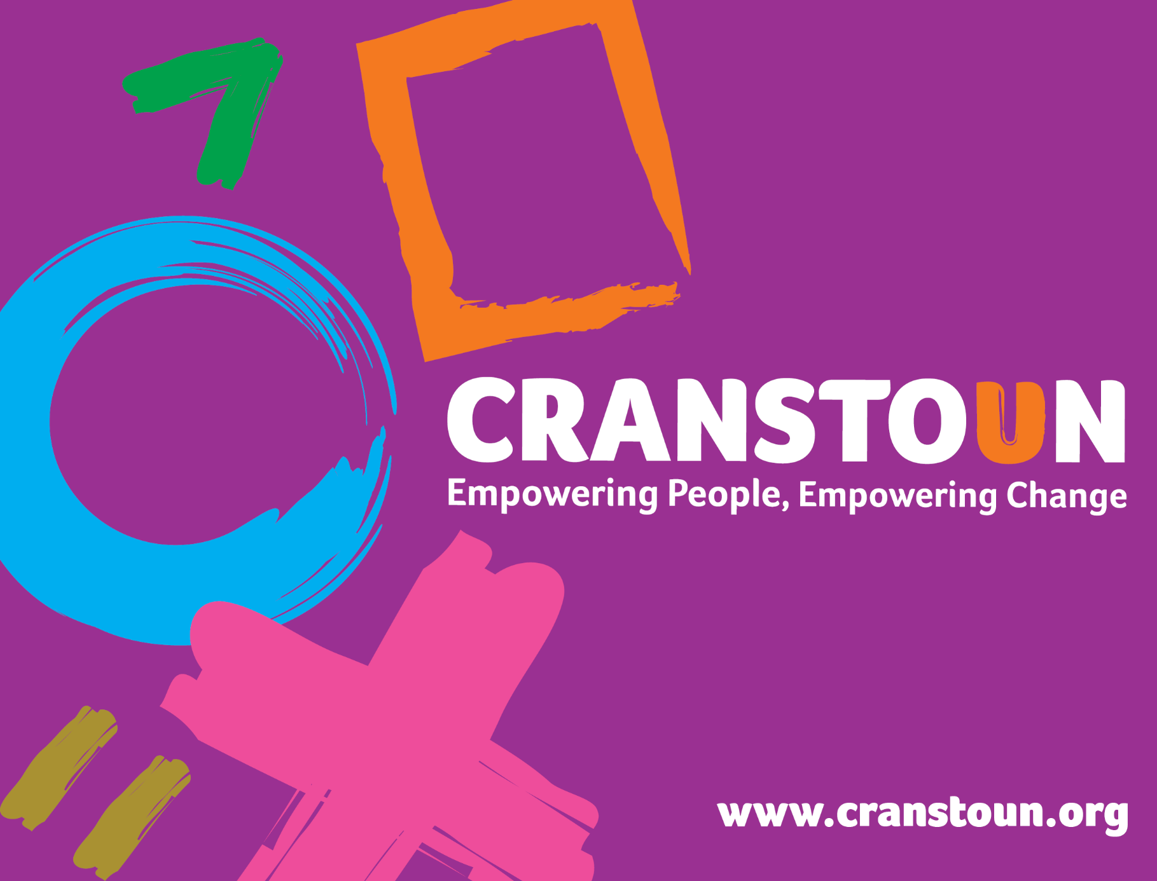

Post Information Pack Dynamic Evolving Model of Outreach (DEMO) Practitioner Service | Cranstoun
Location | Sandwell

Cranstoun is a social justice and harm reduction charity with global ambition.
Vision: To be a world-class leader in rebuilding lives.
Purpose: To inspire and empower people to live healthier and safer lives.
Values: Ambitious, Creative, Compassionate, Collaborative, Respectful.

Job description
Job purpose / context:
- Engage and build connections with people who inject drugs in public spaces in the Sandwell area
- Engage and develop constructive relationships with individuals who use substances and have complex health concerns and limited or no contact with the Sandwell Cranstoun service.
- To provide a high quality service to people with identified drug or alcohol related problems, with the aim of delivering harm reduction interventions and assisting in working towards improving overall health
- Working within a trauma informed approach to provide flexible outreach, advice, advocacy, harm reduction and psychosocial interventions to clients who have a history of problematic substance or alcohol use.
- Work in close partnership with the DEMO Advanced Nurse Practitioner and other agencies to provide support to individuals encountered.
- Support the DEMO research team in their work as required

Responsible to:
Senior/TL for line management support
DEMO Advanced Nurse Practitioner for day to day activities

Specific Post Requirements:
- Able to work flexibly, including out of usual service hours and sometimes alone.
- Build and develop connections and relationships with individuals who have limited contact or no contact with services.
- Proactively engage individuals who have no or very limited contact with the Sandwell drug and alcohol service to deliver outreach based harm reduction interventions, injecting equipment and naloxone provision and blood borne virus testing, working towards reducing the risk of drug and alcohol related harms.
- Proactively engage and support individuals to address health concerns when these are identified.
- Identify barriers to entry into services and support to address these if individuals wish to enter services.
- Build rapport and confidence with this cohort of individuals to enter into and maintain engagement with the drug and alcohol treatment service if individuals wish to do so..
- Respond assertively to track, keep contact and reengage with identified individuals.
- Work in close partnership with the Advanced Nurse Practitioner and with other services including mental health services, primary and secondary care services, local authority and social care services, homelessness and housing services and those with lived/living experience to improve joint working and health outcomes for the identified individuals
- Attend and input into relevant multiagency meetings or forums that support engagement of identified individuals
- Provide advocacy for individuals to support access to partner services.
- Effectively engage with clinical supervision and team meetings

- Role Responsibilities
- Duties and Responsibilities
- Work directly with clients using a trauma informed approach and deliver interventions to support individuals accessing the DEMO team and other services they wish to access.
- Support referral and engagement into services to provide support for continuity of care.
- Carry out triage and comprehensive assessments where there is a defined need to do so, for example to support prescribing interventions
- Co-ordinate the client’s care to enable them to access pharmacological interventions where desired, including opioid substitution therapy, relapse prevention medication or prescribing of emergency medications.
- Comply with organisational policies and procedures in the monitoring and management of client prescribing to ensure safe delivery of interventions.
- In partnership with the DEMO Advanced Nurse Practitioner to undertake a scoping exercise of the Sandwell area to assess need within the geographical boundaries of Sandwell to inform the development and delivery of DEMO service provision.
- Complete risk management and care plans where there is an identified need to do so.
- Complete harm reduction interventions e.g. needle syringe provision, Blood Borne Virus screening, naloxone provision, safer injecting guidance.
- Identify safeguarding issues and respond appropriately as per organisational safeguarding policies and procedures. Seek advice from the local service safeguarding lead or safeguarding champion.
- Work in partnership with other parts of the service towards ‘system change’ for example naloxone training for hostel staff, informing hostel policy towards substance use.
- Assist individuals to explore and plan for future employment, training and education opportunities and assist clients in relation to their aftercare where appropriate.
- Support and encourage peer support and access to mutual aid as required.
- Participate in and plan training for other professionals/groups.
- Provide written and verbal reports as requested by the Advanced Nurse Practitioner, Team Leader, Senior Practitioner or Borough Manager.
- Comply with all Cranstoun policies and procedures.
- Carry out duties which you are deemed competent to perform as directed by the Advanced Nurse Practitioner, County Manager or Team Leader.
2. Advice and Information:
- Raise awareness about substances and alcohol, their use and effects
- Be aware of current national policy directing and supporting drug and alcohol services
- Positively promote the Service throughout the Borough
- Enable individuals to adopt safe practises associated with substance and alcohol use through effective communication of harm reduction as appropriate such as safer injecting practices and equipment selection, naloxone training and provision, blood borne virus transmission, vein care and self-management of injecting related skin and soft tissue infection
- Support service users to understand and manage interactions between substance and alcohol use and other forms of risk taking behaviour such as sex, gambling, domestic violence, self-harm and so on

3. Assessment and Care Planning
- Plan and agree service responses which meet individuals identified needs and circumstances and are in line with both service and national guidelines
- Provide an empathic and friendly approach rooted firmly in a trauma informed stance to individuals, their families and friends, carers and referrers .
- Assist in the transfer of individuals between agencies and services
- Work consistently and persistently with individuals to develop meaningful and effective connections and relationships, with the aim of developing trust and deliver and co-ordinate interventions appropriate to their needs.
- Work alongside individuals without setting time-limited boundaries around engagement.
4. Support
- Support individuals to access and use services and facilities.
- Support individuals who are substance and/or alcohol users
- Enable individuals to manage their financial affairs
- Work with individuals to address their substance and/or alcohol use using recognised models where this is their desired aim
- Where appropriate, co-ordinate access to structured detoxifications, completing the necessary preparatory work to enable this to be successful and delivered safely

5. Monitoring
- Provide information to support decision making
- Ensure records are kept up to date and relevant via the digital database and paper files
- Use the review framework to ensure that the minimum three monthly reviews are adhered to and all paperwork is completed
- Maintain records as adhering to good information governance and in line with Cranstoun and service’s local policies and guidelines
6. General – Professional Practice
- Relate to and interact with individuals from a trauma informed approach.
- Promote peoples equality, diversity and rights
- Promote choice, wellbeing and the protection of individuals.
- Assess and act upon immediate risk of danger to or from substance and/or users.
- Develop your own knowledge and practice
- Make effective use of supervision processes
- Promote the collaborative approach to delivering the service with service users, encouraging active service user involvement and inviting feedback from service users on service provision.

7. Operational Duties
- Contribute to maintaining places of safety for all clients and staff
- Liaise with all referral and partnership agencies and workers as and when appropriate.
- Attend internal and external meetings and training as required.
- Contribute to the development of services and policies.
- Contribute to the research on and evidence base for DEMO.
- Undertake any additional duties as may be reasonably required by the Team Leader or County Manager.

Person specification

Experience
- Educated to level 3 or equivalent (for example NVQ , BTEC) or degree level. Desirable: qualification in substance and alcohol use
- Experience of direct client work with substance use and/or alcohol issues, those experiencing homelessness or a comparable client group.
- Experience of using assessment tools
- Experience of one-to-one work
- An understanding of the needs of substance and alcohol users and excellent knowledge of harm reduction approaches
- Proven ability to engage with people who inject drugs in public spaces

Abilities and attributes
- Courage to bring services into sometimes hidden environments
- Ability to engage people in non-service environments, including the street environment
- Ability to dynamically risk assess harm to and harm from people, in particular in hidden environments
- Ability to develop and maintain effective connections and relationships with individuals who may not want to make any reductions to their substance use
- Ability to work with individuals without having ‘treatment’ expectations and to adapt to an individual’s aims and pace of working.
- The ability to work with individuals on their terms and environment.’.
- Ability to take a pragmatic approach to the delivery of interventions/support.
- Good written and verbal communication skills with a good level of IT skills.
- Highly effective listening skills
- Ability to work effectively and efficiently within a small team and build effective working relationships with other agencies.
- A non-judgemental attitude to substance and alcohol users
- An understanding of risk management
- Ability to organise own workload and manage own diary with minimal supervision.

Skills and Knowledge
- Experience and knowledge of engaging and working with people who inject drugs in public spaces
- An understanding and commitment to deliver support from a trauma informed approach.
- Knowledge of the range of community drug and alcohol services and models of treatment
- Knowledge of co-occurring conditions
- Experience of working in an outreach capacity
- Knowledge of brief intervention methods including Brief Solution Focussed Therapy and Motivational Interviewing

Other

Ability to travel independently and in a timely manner is essential
Ability to work in the outside environment for long periods of time, in all weathers.

