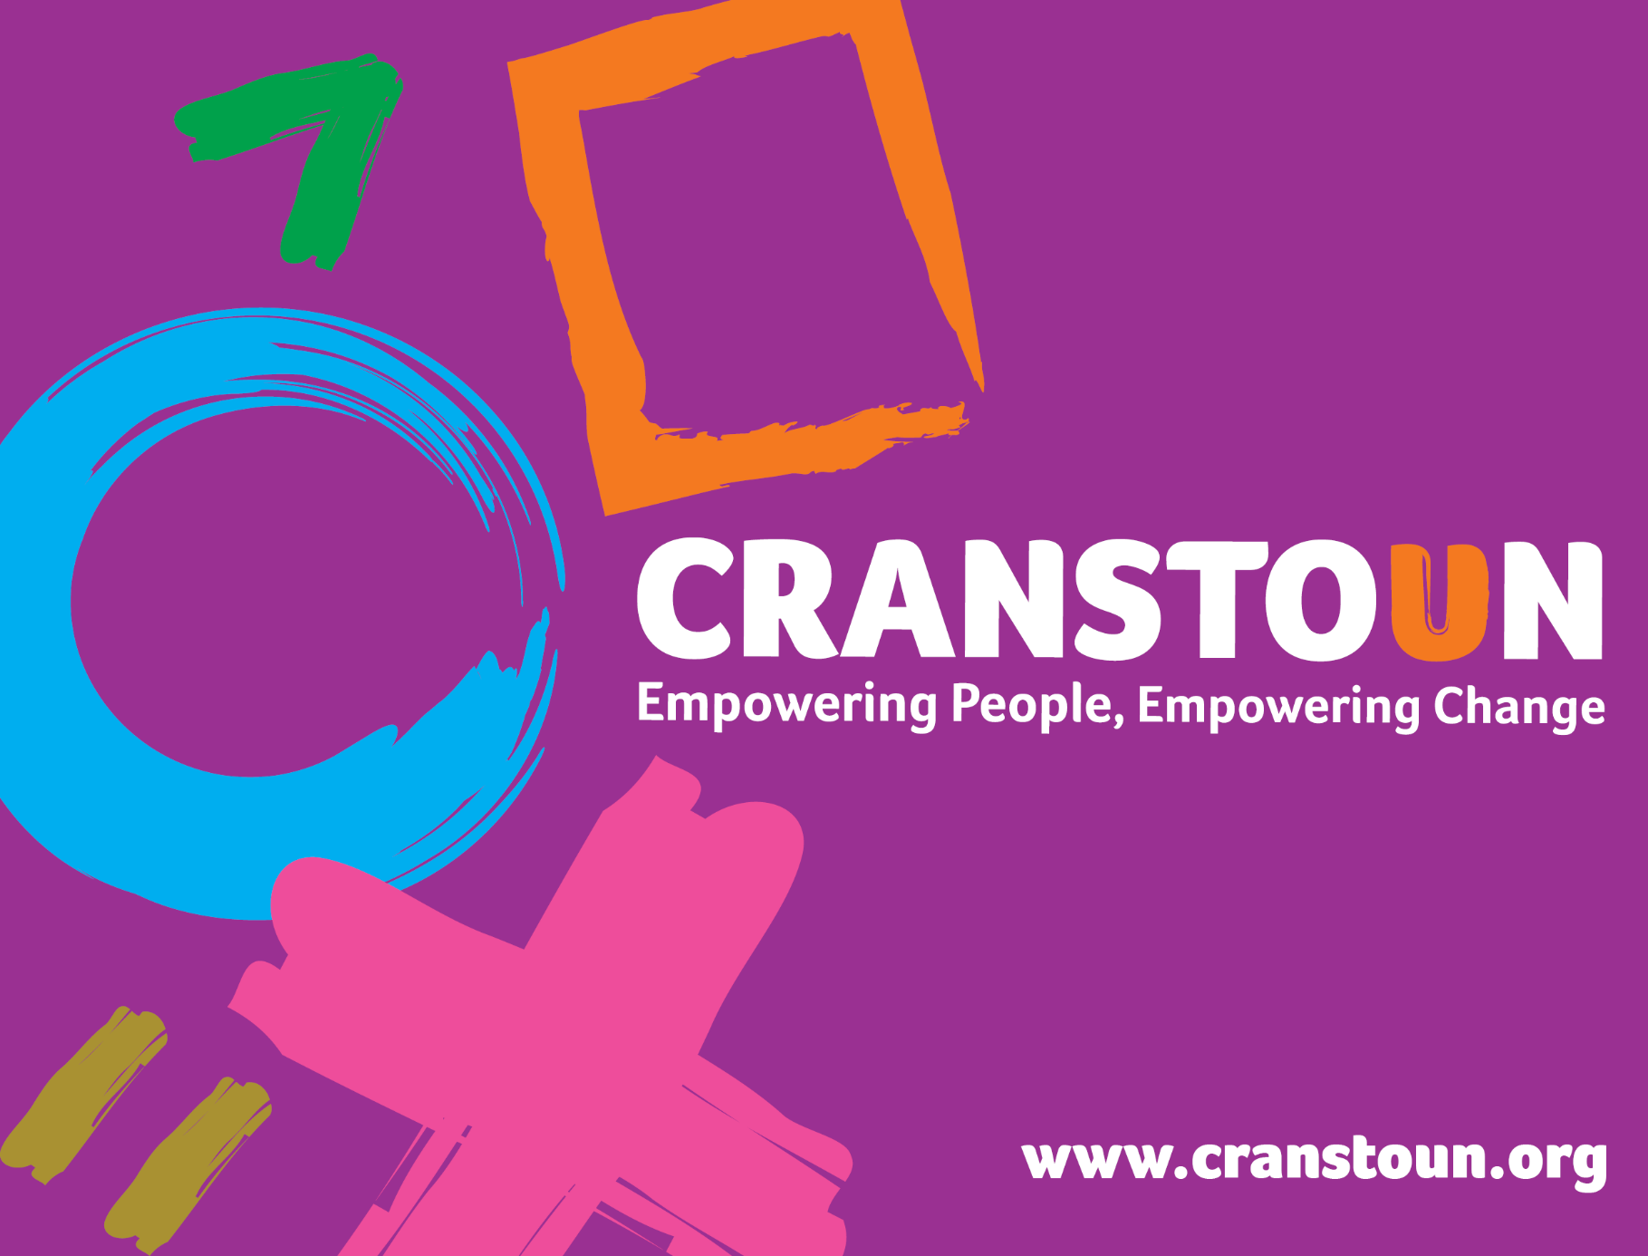

Post Information Pack
Triage/Administrator

Service | Wakefield Domestic abuse Service
Location | Wakefield

Cranstoun is a social justice and harm reduction charity with global ambition.
Vision: To be a world-class leader in rebuilding lives.
Purpose: To inspire and empower people to live healthier and safer lives.
Values: Ambitious, Creative, Compassionate, Collaborative, Respectful.


Job description
Job purpose / context:

- Support all members of the team in providing high quality and comprehensive customer relations and an effective administration function.
- Support and/or undertake a number of administration functions within the office / service
- Be the initial contact with victim survivors and provide a triage function to standard risk/self-referrals.
- Offer information advice and guidance to stakeholders/referrers and to people who use our service
- Act as single point of contact (SPOC) for the service
- Information sharing with partners and mutli-agency meetings such as MARAC, DRAM, IDART.

Responsible to:
Wakefield DASS service manager

Responsible for:
- Administration
- Provide a single point of proactive and regular contact for a range of professionals involved in the reduction of domestic abuse in the Wakefield area.
- Be flexible and willing to work in all types of environments.
- Respond to telecoms contact in a professional manner, ensuring all communication and related tasks are dealt with promptly and efficiently.
- Ensure customer relations are delivered effectively at all necessary times.
- Manage the services email inbox.
- Provide administrative support as directed by the line manager.
- Input referrals and other data onto the case management system
- Attend and take minutes of various meetings when required.
- Draft or issue memos, letters, minutes, and reports in a professional presentable manner. This will include publicity and mail shots.
- Establish & maintain effective and appropriate administration and record keeping systems.
- Ensure collection and distribution of incoming post.
- Ensure daily outgoing post is collected and managed as needed, including special delivery mailings as required.
- Organise and manage courier services as required.
- Ensure copying and printing facilities and technology are working and have sufficient supplies.
- Coordinate servicing and repair of office equipment, as required.
- Maintain sufficient levels of office stationery and supplies.
- Source competitively priced suppliers

- Case management
- Ensure new referrals are inputted onto Cranstoun’s case management system in a timely manner.
- Triage initial referrals into the service (if triage has not been completed)
- Provide information advice and guidance to a range of service users and professionals.

- Attend monthly case management meeting when required.
- Comply with children and adult safeguarding ensuring that service users and colleagues understand and comply with the service’s safeguarding framework.
- Contribute to regular service reviews which include monitoring data.
- Attend monthly case management meeting with the Service Manager and other members of the Wakefield domestic abuse team.
- Attend clinical supervision.
- Take appropriate steps to protect where there is an imminent risk to another person.
- Attend service and external meetings when required acting as minute taker.

- Recording and Administration
- Ensure that case files and records are accurate and complete and are kept and in compliance with General Data Protection Regulations (GDPR).
- To enter all the required information into the agreed case management system.
- Daily maintenance and accurate and secure audit trail of all relevant communication.
- Comply with the data protection and information sharing protocols that Cranstoun has agreed to.
5. General
- Remain up-to-date and compliant with all relevant legislation connected to your work, including organisational procedures, policies and professional codes of conduct and practice guidance, to uphold standards of best practice.
- Represent the service at local events; deliver training and presentations as required.
- Be committed to attending regular training.
- Act with integrity and respect when interacting with service users, employees, agencies, and individuals.
- Competent in defensible decision making, recording, and being held accountable.
- Adhere to the terms and conditions of employment agreed with Cranstoun, working within the policies of the organisation.
- Undertake any additional duties as may be reasonably required and requested from time to time by Cranstoun or project funders.

- Professional practice

- Respond to and interact with individuals with respect and maintain supportive but professional boundaries.
- Promote people’s equality, diversity, and rights.
- Promote choice, wellbeing, and the protection of individuals.
- Take responsibility to use supervision structure and use active participation in the appraisal system.

- Other duties

- Undertake any additional duties as may be reasonably required by the Service Manager.
- Actively support the day to day running of the service.
- This job description is subject to review and revision, as agreed by the post-holder and management team, to maintain a relevance to work undertaken and any changes to the demands of the internal or external environment.

Person specification

The post holder will have a demonstrable track record in the administration of service delivery and working as part of a multi-disciplinary team. The post holder will also be a strong role model of the Cranstoun values: ambition for service users, compassion, innovation, and, integrity.

Experience Essential
- Working in a busy office environment
- Customer service experience
- Working to and meeting deadlines
- Managing time and prioritising workload
- Excellent IT skills and ability to use MS Office (Word, Excel, Outlook, Power Point)
- Evidence of keeping reliable and timely reporting and meeting deadlines

Experience Desirable
- Working within a health and social care setting
- Broad understanding of domestic abuse issues, desirable not essential (training will be provided)

Abilities and attributes
- Have confidence in their own ability to make defensible decisions.
- An ability to work collaboratively as part of a team; whilst also having the initiative to work independently as necessary:
- Excellent communication skills (both written and oral).
- A comprehensive understanding of risk.
- Capacity to manage raw emotions including conflict, challenge and trauma.
- Proactive and self-motivated.
- Ability to manage own time, prioritise activities and maintain accountability for your work
- Maintain confidentiality of all data and information
- Accurate record keeping

Skills
- Ability and willingness to work independently and as part of a team.
- Good relationship management with regard to multi-agency work that incorporates sensitivity, responsiveness and attention to the promotion of congruent and effective partnership working.
- IT skills, including use of Microsoft Office.
- Communication (verbal, written and listening skills), with excellent spelling, grammar and the ability to produce error-free documents
- Using technology
- Telephone skills
- Managing time and prioritising
- Planning and organising
- Attention to detail
- Able to be responsive and reactive
- Self motivation and management of own workload
- Working on own, using initiative, as well as being an enthusiastic team player
- Supporting others
- Problem solving and questioning
- Researching
- Monitoring and evaluating
- Empathy
- Have excellent interpersonal skills.
- Excellent networking skills and the ability to develop strong working relationships with other agencies.
- Willingness to undertake identified training.

Knowledge

- Knowledge of Microsoft Office products
- Broad understanding of domestic abuse issues, desirable not essential (training will be provided)

